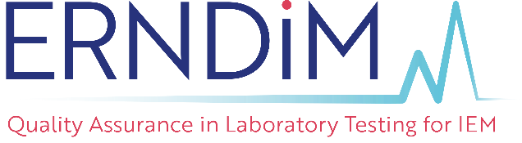
Administration Office
c/o EMQN CIC
Third Floor, ICE Building,
3 Exchange Quay, Salford
M5 3ED, United Kingdom.
Tel: +44 161 757 4952
Fax: +44 161 850 1145
Email: admin@erndim.org

POLICY ON USE OF ERNDIM LOGO AND
WEBSITE MATERIALS
- SCOPE
This document describes the ERNDIM policy on the use of its trademarked logo and website materials by external organisations and other third parties. These conditions shall be met by all organisations and third parties, including those outside the United Kingdom.
- COPYRIGHT STATEMENT
  - The ERNDIM name and logo are the property of the European Research Network for evaluation and improvement of screening, Diagnosis and treatment of Inherited disorders of Metabolism (ERNDIM), a not for profit charitable foundation registered with the Maastricht Chamber of Commerce (Kamer van Koophandel, www.kvk.nl/english, registration number 41078752). Use of the name or logo (or closely similar derivative) by any other body or individual is strictly prohibited.
  - ERNDIM asserts its ownership and copyright of all material on its website.
  - Any individual or organisation which shares the educational and scientific aims of ERNDIM may copy material from this website for personal use or study without restriction. However, permission must be sought from the ERNDIM Administration Office if any material is to be published in any form or presented at any public gathering or passed on to third parties. Permission will normally be granted if an appropriate statement of attribution is included and the material is presented intact.
- FORM AND DISPLAY OF THE LOGO
  - The ERNDIM EQA scheme participant logo may be used to illustrate that an organisation participates in EQA schemes run by ERNDIM. The context of the placement of the logo must not infer that the laboratory or organisation is approved, certified or accredited by ERNDIM. When used on a web site, the logo image must be hyperlinked to www.erndim.org.
  - Only approved images of the participant logo may be used. Copies of the logo may be obtained from the ERNDIM office (admin@erndim.org).
  - The main ERNDIM logo may not be used by any organisation or third party except when agreed in writing by ERNDIM.
- LINKING
  - As an independent, non-profit making, professional organisation concerned with the quality of clinical laboratory investigations, ERNDIM is happy to co-operate and collaborate with sister organisations and societies in laboratory medicine and related fields. Links from the website may therefore be made to appropriate bodies. The ERNDIM Administration Office will endeavour to contact the relevant organisation when a link is made.
  - Any individual or organisation which shares the educational and scientific aims of ERNDIM may place a link from their web site to the ERNDIM website, providing the site contains no content that would bring ERNDIM into disrepute, interfere in any way with its aims and objectives, or affect public or professional perception of its activities. Webmasters are requested to contact the ERNDIM Administration Office by email when the link is made. If the linking site is considered suitable, a reciprocal link from the Links area of the ERNDIM site will be made.
  - ERNDIM cannot be responsible for the content of linked sites.
- CONTACTS.0
  - Contact information is provided for the use of bona fide persons seeking information about ERNDIM services or contributing information of relevance to its service and/or objectives.
  - Use of contact details for any other purpose without permission will be actively opposed.
Medical advice cannot be given to persons making contact with ERNDIM; please do not seek it.

