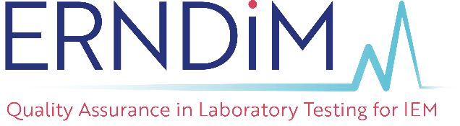 |  | Administration office  c/o EMQN CIC, Unit 4, Enterprise House,  Manchester Science Park, Pencroft Way,  Manchester M15 6SE, United Kingdom.  Tel: +44 161 757 4952  Fax: +44 161 850 1145  Email: admin@erndim.org

ERNDIM Laboratory Support Grant Application Form
A limited number of grants are available to provide financial support for laboratories which due to financial restrictions find it difficult to fund participation in one or more of the ERNDIM EQA schemes.
Laboratory Support Grants are awarded annually by ERNDIM on a competitive basis with the aim of allowing laboratories to extend their repertoire of EQA scheme participation.
Grants are awarded for one year in the first instance with the option of reapplying for a reduced grant in successive years. The expectation being that in the following years laboratories will secure substantive funding to support long term participation in the EQA scheme(s).
All applications for support during the 2024 scheme year must be received during the registration period, please see the ERNDIM website for dates.
If you would like to apply for a Laboratory Support Grant please provide the following information:
1. Laboratory Name:
Address:
ERN Number:
2. How is your laboratory funded? (please tick)
 |  |  | Public |  |  |  |  |  |  | Mixed public/private
 |  |  | Private/commercial |  |  |  |  |  |  | Other
 | If you selected ‘Other’ please give details:
3. Please state which EQA Scheme(s) you are applying for support to participate in & the Number of diagnostic analyses per year performed by your laboratory?
 |  | Name of EQA scheme(s) |  |  |  |  |  |  |  |  |  |  |  |  |  | Number of analyses/year
5. How many other laboratories provide this analysis in your country?
6. Supporting Documents (please attach to your application)
 |  | 1. A statement on why support is needed.
 |  | 2. A statement on the organisation of Biochemical Genetic Testing in your country and your own role within this.
Head of Laboratory
Signature: |  |  |  |  |  |  |  |  |  |  |  |  |  |  | Date:
Name:
Position:
Director / Head of Hospital / Institution approval
Signature: |  |  |  |  |  |  |  |  |  |  |  |  |  |  | Date:
Name:
Position:

- By signing this form you are agreeing that ERNDIM can process, share and store your data for the purposes of processing this laboratory support grant application only.
- Any personal information you supply to ERNDIM on this form will be treated in accordance with the ERNDIM Privacy Policy (which can be found on www.erndim.org) and the EU General Data Protection Regulation (GDPR).
- We will only communicate with you or share your data with a third party for purposes related to processing this laboratory support grant application unless you have consented elsewhere that we can contact you or share your data for other reasons.
- We will not share your data with third parties for marketing purposes.

Completed application forms should be returned to the ERNDIM Administration Office at the address below.
ERNDIM Administration Office  c/o EMQN CIC, Unit 4, Enterprise House,  Manchester Science Park, Pencroft Way,  Manchester M15 6SE, United Kingdom. | Tel: +44 (0) 161 757 4952  Fax: +44 (0) 161 850 1145  Email: erndim@mft.nhs.uk  admin@erndim.org
All applications for support during the 2024 scheme year must be received during the registration period, please see the ERNDIM website for dates.
Applicants will be notified of the outcome of their application within 4 weeks of the date the completed application is received.

