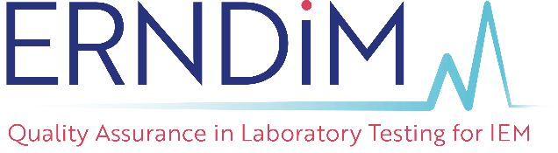 |  | Administration Office  c/o EMQN CIC, Unit 4, Enterprise House,  Manchester Science Park, Pencroft Way,  Manchester M15 6SE, United Kingdom.  Tel: +44 161 757 4952  Fax: +44 161 850 1145  Email: admin@erndim.org
INFORMATION FOR CLINICIANS AND SCIENTISTS ON DONATING SAMPLES FOR USE AS EQA MATERIALS
ERNDIM and EQA
ERNDIM provides External Quality Assurance (EQA) material to over 400 laboratories, in 60 countries, that offer diagnostic services for patients suspected of having a metabolic disorder. Further details about ERNDIM are available on our website: (www.erndim.org) alongside details of all of the EQA schemes that we provide (http://www.erndim.org/home/qascheme.asp).
The clinical value of the tests offered and the accuracy, reliability and especially comparability of quantitative results is underpinned by accreditation and the operation of suitable EQA schemes. Together, they play a vital role to safeguard and improve the reliability of testing for the doctors and patients that use these services. There is already considerable evidence that performance in biochemical genetic testing has improved directly due to EQA scheme membership.
Over recent years we have been able to distribute samples from patients with a wide range of inborn errors including amino acid, organic acid, energy metabolism, mucopolysaccharide, sphingolipid storage, purine/pyrimidine, peroxisomal and creatine synthesis disorders but now our resources are becoming stretched and it is becoming difficult to source suitable samples for use as EQA materials.
Useful samples
Therefore we issue a plea to all our colleagues in clinical practice for help in obtaining samples from patients with known conditions. Details of the types of samples we require are below.
 | Disorders | Material | Volume needed | Comments
1. | From patients with organic acidurias, aminoacidopathies and purine/pyrimidine disorders | Urine | from 300mL to 2L | Random aliquots, not necessarily a continuous collection can be kept in a normal freezer during the collection period
2. | Mucopolysaccharides in urine from patients with known disorders | Urine | 500 mL to 2L | As above
3. | Acyl carnitines in blood spots from patients with known disorders | Whole blood | 3 - 3.5 mL | Blood collection in lithium heparin tubes is preferred
4. | Congenital disorders of Glycosylation (CDG) from patients with known disorders | Plasma | >3.5mL
Donating a sample
If you would be able to collect a sample, with the appropriate consent, that would be useful to ERNDIM please contact the ERNDIM Administration Office who will send you the ERNDIM consent form and details of how and where to send the samples.
Transport of the samples to ERNDIM can be organised through your local Biochemical Genetic testing lab and ERNDIM will pay reasonable transport costs for pre-agreed samples but please contact ERNDIM (admin@erndim.org) before sending any samples. Please do not send any samples to the ERNDIM Administration Office.
If you have any questions please contact the ERNDIM Administration Office (admin@erndim.org).

