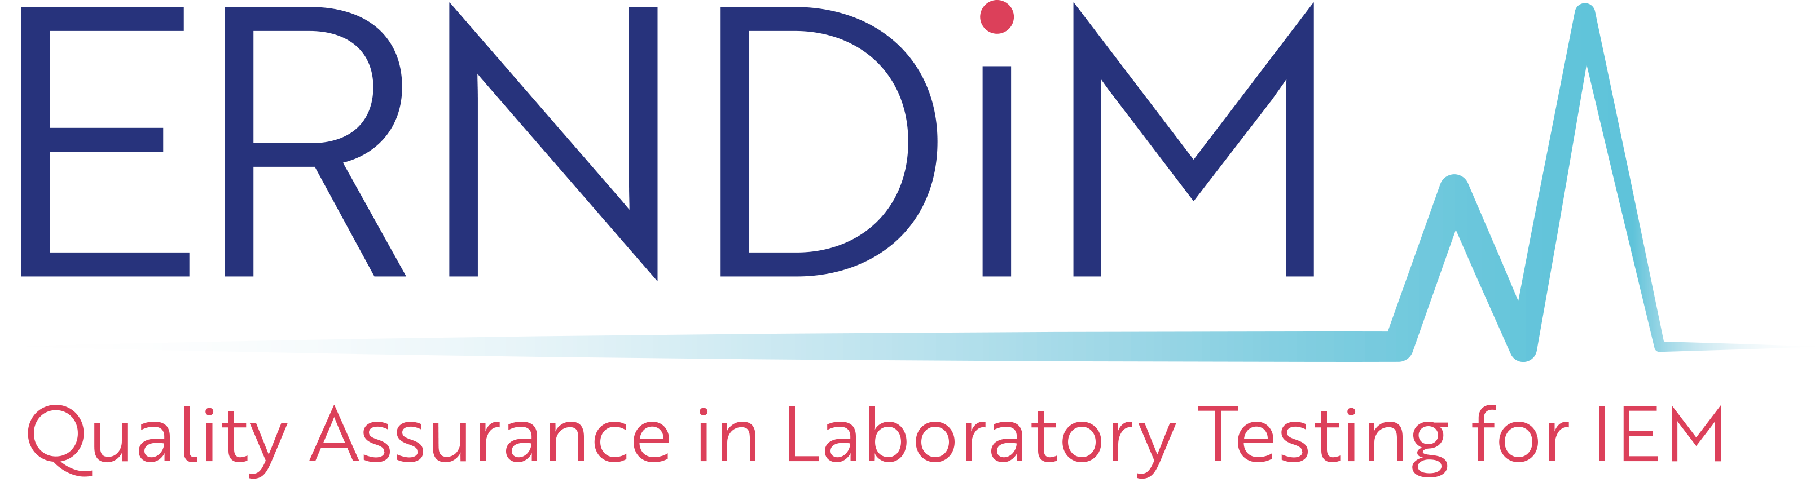 |  | Administration Office  c/o EMQN CIC, Unit 4, Enterprise House,  Manchester Science Park, Pencroft Way,  Manchester M15 6SE, United Kingdom.  Tel: +44 161 757 4952  Fax: +44 161 850 1145  Email: admin@erndim.org

ERNDIM Training Grant Application Form
- Information
- This grant is designed for trainees, in a permanent laboratory position, to gain experience and knowledge in a European ERNDIM approved laboratory in order to develop or introduce new methods to their own laboratory.
- Funds can be applied for to cover the travel and accommodation costs incurred by such visits. Funds to cover subsistence costs cannot be applied for and will not be included in any awarded grants. Reasonable quotes should be provided for all costs included in an application.
- A maximum of 6 grants will be awarded each year subject to the approval of the ERNDIM Executive Committee. ERNDIM reserves the right to limit the funds approved for individual grant applications if the costs included in an individual application are deemed excessive.
- If approved, grant funds will be paid upon completion of a Training Grant Claim form (available from the ERNDIM Administration Office) and submission of original receipts, and usually after the completion of the laboratory visit. However costs which are paid by the applicant before the dates of the agreed laboratory visit (e.g. flights) can, with the pre-agreement of the Administration Office, be claimed in advance with submission of original receipts.
- Only costs included in the original Training Grant application and which were approved by the ERNDIM Treasurer will be paid by ERNDIM.
- The final amount claimed should not significantly exceed the amount approved by the ERNDIM Treasurer and ERNDIM reserves the right to limit the grant paid to the sum which was approved by the ERNDIM Treasurer.
- In case of any disagreement between ERNDIM and the applicant, the decision of the ERNDIM Treasurer will be final.
- Approved funding must be used within 6 months of approval and a short report, which will be posted on the ERNDIM website, must be written within 4 weeks of the visit to the Host laboratory.
- All claims for costs should be received by the Administration Office by the 1st December in the year the grant was approved.
- If you would like to apply for an ERNDIM Training Grant please complete the form on the following page and return it to:
ERNDIM Administration Office
c/o EMQN CIC, Unit 4, Enterprise House,
Manchester Science Park, Pencroft Way,
Manchester M15 6SE, United Kingdom.
Tel: +44 161 757 4952
Fax: +44 161 850 1145
Email: admin@erndim.org
- Deadlines for submission are the 31st March, 31st August and 31st December of each year. Applicants will be notified of the outcome of their application within 4 weeks of the submission deadline. The decision of the ERNDIM Treasurer is final.
- Training Grant Application Form
1. Applicant Details
Name:
Post:
Email:
Laboratory Name:
Address:
2. Proposed Host Laboratory
Name:
Address:
Date of planned visit:
3. Please briefly described the training required: (continue on a separate sheet if necessary)
4. Why is this important for your laboratory? (continue on a separate sheet if necessary)
5. Please give details of the costs (in Euro) which you are applying for funding for.
 | List Items (e.g. air or train fare, accommodation) & attach relevant quotes |  |  |  |  |  |  |  |  |  | Cost (Euro)
 | Total:
Head of Laboratory
Signature: |  |  |  |  |  |  |  | Date:
Name:
Position:
Head of Host Laboratory approval
Signature: |  |  |  |  |  |  |  | Date:
Name:
Position:
Data protection
– By signing this form you are agreeing that ERNDIM can process, share and store your data for the purposes of processing this Training Grant application only.
– Any personal information you supply to ERNDIM on this form will be treated in accordance with the ERNDIM Privacy Policy (which can be found on www.erndim.org) and the EU General Data Protection Regulation (GDPR).
– We will only communicate with you or share your data with a third party for purposes related to this processing this Training Grant application unless you have consented elsewhere that we can contact you or share your data for other reasons.
– We will not share your data with third parties for marketing purposes.

